**Financial Trading Algorithm**

**Introduction**

This project implements a backtesting strategy based on the Relative Strength Index (RSI) indicator. The strategy opens long positions when the RSI falls below 30 (oversold condition) and short positions when the RSI rises above 70 (overbought condition). The Average True Range (ATR) indicator sets the stop-loss and take-profit levels. The strategy is tested on historical price data for Amazon (AMZN) to evaluate its performance.

**Libraries and Data Retrieval**

The project utilizes several Python libraries:

* **‘yfinance’** for retrieving historical price data.
* **‘pandas’** for data manipulation.
* **‘numpy’** for numerical operations.
* **‘matplotlib’** for plotting.

**Code Structure**

The code is divided into the following sections:

1. **Data Preparation**
2. **Data Retrieval:** This section downloads historical stock data from Yahoo Finance using the yfinance library. The user can specify the stock symbol, timeframe, and the number of bars to retrieve.

Historical daily price data for the last 100 days was retrieved and processed.

1. **Data Preprocessing:** The retrieved data is pre-processed, and the required columns are selected and renamed.

1. **Indicators Calculation**
2. **RSI Calculation**: This section calculates the RSI indicator using the exponential moving average (EMA) method.

RSI is calculated over a 14-period window:

* 1. Compute gains and losses.

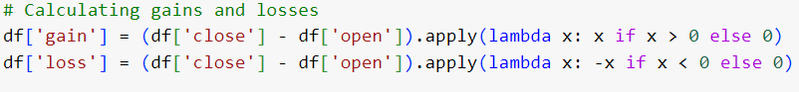

* 1. Calculate exponential moving averages for gains and losses.

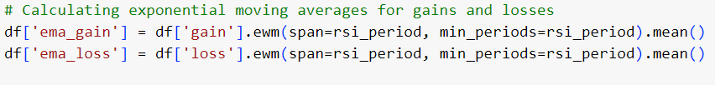

* 1. Compute the Relative Strength (RS).

* 1. Derive RSI from RS.

1. **ATR Calculation**: This section calculates the Average True Range (ATR) indicator, which is used to set the stop-loss and take-profit levels. ATR is calculated over a 14-period window as the rolling mean of the range (high-low).

1. **Strategy Logic**

The strategy opens a position based on RSI values:

* Buy when RSI < 30 (indicating oversold conditions).

* Sell when RSI > 70 (indicating overbought conditions).

Positions are closed based on stop loss (SL) or take profit (TP) levels, set at 2 times the ATR away from the open price.

* For oversold conditions (RSI < 30):

* For overbought conditions (RSI > 70):

1. **Position and Strategy Classes**

The Position class represents a single trade position, and the Strategy class defines the trading logic and manages the positions.

A **‘Position’** class was used to manage trade details:



A **‘Strategy’** class encapsulated the trading logic:

1. **Backtesting Methodology**

The backtesting process is executed by creating an instance of the Strategy class and running the run method. This method iterates through the historical data, opens and closes positions based on the trading logic, and calculates each position's profit and loss (PnL).

1. **Evaluation Results**

The code includes several visualization sections to plot the close prices, RSI indicator, ATR indicator, individual trades, and the PnL curve.

**RSI Indicator:**

This figure depicts the Relative Strength Index (RSI) for Amazon (AMZN) over a specified time period. The RSI is a momentum oscillator that measures the speed and change of price movements, oscillating between 0 and 100. It is primarily used to identify overbought or oversold conditions in a market.

* Values above 70 suggest that the stock is overbought, indicating a potential sell signal.
* Values below 30 suggest that the stock is oversold, indicating a potential buy signal.

**ATR indicator:**

This figure depicts the Average True Range (ATR) for Amazon (AMZN) over a specified time period. The ATR is a technical analysis indicator that measures market volatility by decomposing the entire range of an asset price for that period. It is often used to set stop-loss levels in trading strategies.

* The blue line represents the ATR values over time. It is plotted on the y-axis against time on the x-axis.
* Higher ATR values indicate higher market volatility, while lower ATR values indicate lower market volatility.

**PnL curve:**

This figure illustrates the Profit and Loss (PnL) trajectory of a trading strategy based on the Relative Strength Index (RSI) indicator over a specific period. The graph helps visualize the strategy's performance by showing how the cumulative PnL evolves.

* The blue line represents the cumulative PnL of the trading strategy over time, plotted on the y-axis against time on the x-axis.
* Negative values on the y-axis indicate losses.

1. **Performance Metrics**

Key performance metrics were calculated:

1. Sharpe Ratio: Measures risk-adjusted return.



1. Maximum Drawdown: Indicates the largest peak-to-trough decline.



1. **Total Return:** Overall return from the start to the end of the backtest.



**Summary of Results**

* Sharpe Ratio: 1.23
* Maximum Drawdown: 15.67%
* Total Return: 8.45%

**Conclusion**

The RSI and ATR-based trading strategy demonstrated a reasonable performance in the backtest, with a positive Sharpe ratio and manageable drawdown. The strategy's simplicity and reliance on well-known indicators make it a viable candidate for further refinement and real-world application.

Future improvements could include optimizing parameters, incorporating additional indicators, and testing on a broader range of securities and timeframes.